Materials and methods

Materials and methods
I- Materials:
Chemical materials:
1-Bisphenol A (BPA) :
In the form of crystalline white powder dissolved in canola oil. The chemical is from LOBA Chemie, Pvt. Ltd. 107, Wodehouse Road, Mumbai 400005 India. The connection with this company is through LEC company for chemicals in Benha.
For preparation of a solution of BPA with concentration of 250 μg of BPA /ml : 250 mg of BPA were added to 100 ml of canola oil . Each 1 ml of the formed solution contained 2.5 mg of BPA. Then , 1 ml of this solution was added to 9 ml of canola oil . Each 1 ml of the formed solution contained 250 μg of BPA .
For preparation of a solution of BPA with concentration of 25 μg of BPA /ml : 1 ml of the previously prepared solution was added it to 9 ml of canola oil. Each one ml of the formed solution contained 25 μg of BPA .
2-Indole 3 carbinol (I 3 C).
In the form of white powder. The chemical is from LOBA Chemie, Pvt. Ltd. 107, Wodehouse Road, Mumbai 400005 India. The connection with this company is through LEC company for chemicals in Benha. The drug was added to the chow in dose of 2 g / kg chow once daily. Then the chow was wetted by water to ensure the attachment of the drug to it.
Animals:
Fifty adult female and 25 adult male albino rats were used in the study , their weight ranged from 200-250 gm each. They were obtained from animal house , Faculty of Veterinary Medicine , Benha University and were kept in the experimental animal unit , faculty of medicine , Benha University . The rats were maintained under standard conditions in metal cages (2 rats / cage ) at temperature 22 ± 2°C , humidity 55 ± 20% and with 12 hours dark/light cycle. They were allowed to free access to water supplied from glass bottles and to a balanced chow prepared in the experimental animal breeding farm , Helwan, Cairo. All aspects of the research were compiled with the protocols approved by local ethical committee of Faculty of Medicine , Benha University.
After a 1-week acclimatization period , each 2 Females were caged overnight with one adult male. The day that sperms were found in the vagina (detected by microscopically examined vaginal swap) was designated day zero of pregnancy (Dettlaf and Vessetzky, 1991).
After completion of the study and sampling , we get rid of the rats in Benha University Hospital Incinerator.
II- Methods:
Pregnancy was proved and timed in only 40 female rats. These rats were divided equally into five groups:
1- Negative control group:8 rats did not receive any medication.
2- positive control group: 8 rats received the solvent , canola oil orally by gavage in dose of 1 ml /kg bw once daily (Brandt et al., 2014) from 8th day of pregnancy up to day 21.
3- Indole group : 8 rats received 2 g I3C / kg chow once daily (Brandt et al., 2014) from 8th day of pregnancy up to day 21.
4- Bisphenol group: 8 rats were subdivided equally into two subgroups:
- Subgroup (4 a) :4 rats received 1 ml / kg bw from the solution with concentration of 25 μg of BPA /ml , orally by gavage once daily (Brandt et al., 2014) from 8th day of pregnancy up to day 21.
- Subgroup (4b):4 rats received 1 ml / kg bw from the solution with concentration of 250 μg of BPA /ml , orally by gavage once daily (Brandt et al., 2014) from 8th day of pregnancy up to day 21.
5- Bisphenol and indole group: 8 rats were subdivided equally into two subgroups:
- Subgroup (5a):4 rats received 1 ml / kg bw from the solution with concentration of 25 μg of BPA /ml , orally by gavage once daily , plus 2 g I3C / kg chow (Brandt et al., 2014) from 8th day of pregnancy up to day 21.
- Subgroup (5 b): 4 rats received 1 ml / kg bw from the solution with concentration of 250 μg of BPA /ml , orally by gavage once daily , plus 2 g I3C / kg chow (Brandt et al., 2014) from 8th day of pregnancy up to day 21.
After labour, pups were left with lactating mothers for 2 weeks. Then they were separated from their mothers until day of sacrification at 1 , 3 and 5 months after birth.
After the experiment the rats of each group were subdivided into 3 subgroups:
- The 1st subgroup was killed at 1 month after birth.
- The 2nd subgroup was killed at 3 months after birth.
- The 3rd subgroup was killed at 5 months after birth.
The rats of each group were anaesthetized by light ether inhalation, then each rat was placed on its back on a polystyrene foam wrapped in foil, and the four limbs were spread. All four limbs were pinned firmly using 16 to 20 gauge needles.
The anterior thoracic wall was incised so that the rapidly beating heart becomes visible, then the blood sample was taken from the right ventricle by sterile syringe. Blood samples were incubated at 37°C until blood clotted and then centrifuged at 3000 revolution per minute for 15 minutes for separation of serum and stored at -20 °C for biochemical analysis of testosterone of male rats and estrogen in female rats according to the instruction in the corresponding enzyme-linked Immune-sorbent assay kits.
prostate specimens were collected from rats as following:(photograph 7)
- A V-shaped abdominal incision with its apex at the symphysis pubis was made through all layers. The lower abdominal viscera were thus widely exposed.
- The urinary bladder and ventral lobes of the prostate were freed carefully by sharp dissection
- The urinary bladder and seminal vesicles were reflected to one side to reveal the ventrolateral boundary of the lateral lobe.
- The ventral and dorsolateral lobes were excised and removed
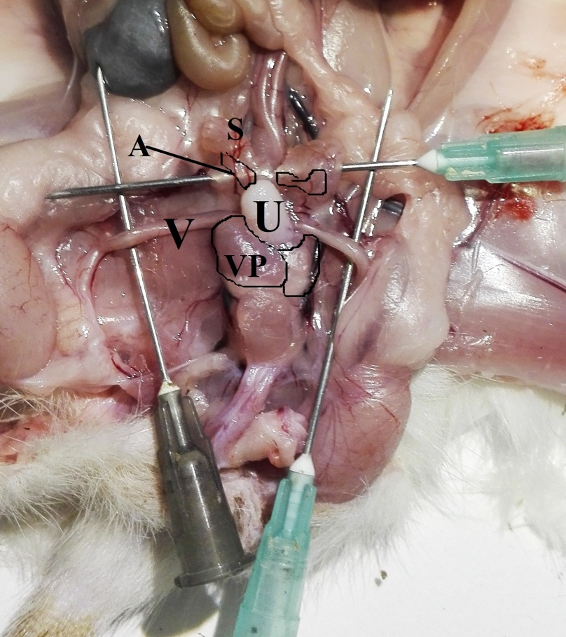
photograph (7):Exposure of prostate gland in rat aged 5 months. S-seminal vesicle , V- vas deferens , U- urinary bladder , A –anterior lobe of prostate , VP- ventral lobe of prostate.
Mammary gland specimens were collected from female rats as following:
The abdominal and inguinal mammary glands were excised and removed their covering skin (photograph 8).
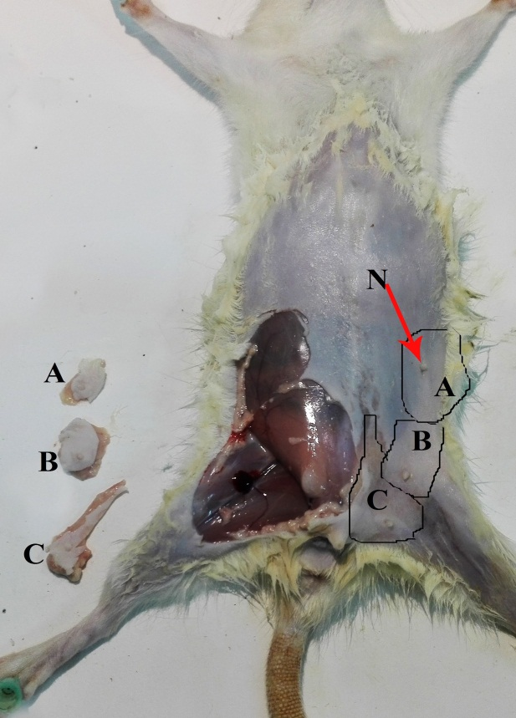
photograph (8): collection of abdominal and inguinal mammary glands from female rat aged 5 months. The glands are in place on left side and are removed on right side. A-abdominal gland , B-cranial inguinal gland , C-caudal inguinal gland , N- nipple

Some prostate and mammary glands specimens were prepared for light microscopic analysis using Hematoxylin & Eosin and Masson's Trichrome staining and other specimens were prepared for electron microscopic analysis.
Hematoxylin and Eosin (H&E) staining: (Bancroft et al. , 2018).
The collected specimens were fixed in 10% neutral buffer formalin. The fixed samples were then embedded in paraffin and sectioned (5 μm thick) on gelatin precoated slides. They were further deparaffinized, stained with hematoxylin and eosin stain , with which the nuclei appear blue and the Cytoplasm appears pink. The sections were photographed using a digital camera (Axioskop MRc5; Carl Zeiss, Oberkochen, Germany) attached to the microscope (Axioskop 40 , Carl Zeiss, Germany) in Anatomy and Embryology Department, Benha faculty Of Medicine, Benha University
Masson's Trichrome stainig: (Bancroft et al. , 2018 ).
For identification of connective tissue.
Technique:
Paraffin sections were processed in the following solution.
- Xylene for 5 minutes.
- Sections were brought down to water.
- Nuclei were stained with iron heamatoxylin for 3 minutes, then washed in tap water.
- Stained in the red cytoplasmic stain (Panceau acid Fuchsin solution) for 5-10 minutes.
- Tap water for 2 minutes.
- Differentiated in 1 percent phosphomolybdic solution for 5-15 minutes until collagen is decolorized.
- Tap water for 2 minutes.
- Counter stained in methyl blue for 5 minutes.
- Washed well in 1% acetic acid for at least one minute.
- Absolute alcohol for 2 minutes and cleared in xylene.
- Sections were mounted in synthetic resin medium. Then examined under microscope.
Results : collagen fibers appear blue or green.
Preparation of ultrathin sections for electron microscopic ( EM ) examination: (Bancroft et al. , 2018 )
The electron microscopic preparation was done at Transmission
Electron Microscope Unit of at Faculty of Medicine, Tanta University, Tanta, Egypt.
The specimen was divided into small pieces (1mm) during immersion in few drops of the fixative and they were subjected to the following steps:
- Fixation: The small tissue pieces were fixed as soon as possible in 2.5 % buffered gluteraldehyde solution at PH7.3 for 3 hours at 4°C then washed three times (10 min for each)in phosphate buffer solution. Then, it was left in buffer over night at 4°C.
- Dehydration: This was done by ascending grades of ethanol concentration (30%, 50%, 70%, 80%, 90%, 100%), 15 minutes each. Finally dehydration in absolute ethanol, 2 changes, each for 15 minutes.
- Transitional solvent: it was put in 2 changes of propylene oxide for 30 minutes each.
- Embedding: Each specimen was transferred into the tip of inverted polythene beam capsule filled with liquid resin.
- Polymerization: Capsules were heated in a temperature -controlled oven at 60°C for 48 hours.
- Trimming: The polymerized block was trimmed into a pyramid with a small trapezoid surface.
- Sectioning: Semithin sections were cut at 1 μm thickness with a glass knife. They were stained with 1% toludine blue stain dissolved in 1% borax for approximately 30-60 seconds at 60-70°C and examined by the Olympus light microscope for general orientation.
- Mounting: Ultrathin sections: 50 nm thick were obtained from the selected blocks and mounted on copper grids (mesh size 200).
- Staining: The grids were stained with a drop of saturated solution of uranyl acetate for 7 minutes, rinsed in distilled water, then stained with a drop of lead citrate for another 7minutes, rinsed in distilled water, then put on a filter paper and left to dry, then stored in grid box till examined by Joel electron microscope at 80 Kilo volt. The selected fields were photographed, and then the photos were magnified.
- Examination: After that the grids were stained and examined by JEOL, JSM-52500 LV scanning electron microscope, Japan , at Electron Microscope Unit of Faculty of Medicine, Tanta University, Tanta, Egypt. Finally, the electron micrographs were taken from the selected areas.

Statistical Analysis
The data of estrogen and testosterone serum levels were presented as mean ± standard error of mean (mean ± SEM). Statistical analysis was performed using one-way analysis of variance (ANOVA) test by using computerized Statistical Program for Social Sciences( SPSS program) version 23 to detect significant differences between the studied groups. Probability (P) values of < 0.05 should be considered statistically significant.

